Creating a Works Cited Page

The following guidelines and sample works cited will assist you in formatting your works cited.

- Begin your Works Cited on a separate page after the last page of your research paper
- There should be a 1 inch margin on all sides of the page
- Use Times New Roman 12 point font; nothing in bold, only titles in italics
- Center the words Works Cited at the top of the page as a heading
- Doublespace all lines
- All entries should be listed in a hanging indent format; to create a hanging indent in Word 1997-2003
  - Place the cursor in the first entry, select Format, then Paragraph.
  - Under Indentation, use the Special drop down box to select Hanging.
- Arrange the items in your Works Cited alphabetically by author’s last name
- If an entry has no author, arrange it by the first word of the title (exclude the words a, an, and the)
- Each in-text citation must be referenced in the Works Cited list
- Each entry in the Works Cited list must be cited at least once in text

Each entry in hanging indent format!
1 “ Margins

Works Cited

A
lphabet
i
cal

Order
“Alexander the Great”. Historic World Leaders. 1994. Biography Resource Center. Web. 16 May 2009 <www.galegroup.com>.
Titles of books, magazines, and databases are in italics
Collins, Ronald K. L., and David M. Skover. The Trials of Lenny Bruce: The Fall and Rise of an American Icon. Naperville: Sourcebooks, 2002. Print.
Double-spacing between and within citations
“Genetics and the Law.” Encyclopedia of Bioethics. New York: Macmillan, 1995. 967-976. Print.
Grieve, Tim. “Catherine the Great.” BBC: Historic Figures. Web. 5 Oct. 2007 <www.salon.com>.
Truncate URLs
King, Stephen. Black House. New York: Random, 2001. Print.
Pepin, Ronald E. Literature of the Twelfth Century. Lewiston: Edwin Mellen Press, 1988. Print.
Include CITY of publication only!
“Tigers”. New Encyclopaedia Britannica. 1997. 767. Print.
All in Times New Roman 12 point font
1 “ Margins
Using Parenthetical Citations
As well as helping you to avoid plagiarism, the purpose of using parenthetical citations in a reference paper is
- to briefly let your reader know that you are using the words or ideas of another author
- to direct your reader to a complete citation of the work you are using in your Works Cited list
- to identify the location of the borrowed information in that work as specifically as possible
The parenthetical citation generally consists of two parts ( see variations on these basic rules below:
- the authors name directs your reader to an entry in your “Works Cited” list,
- a page or paragraph number directs your reader to a specific section of the work.
You must cite your source when you use a direct quote AND when you rewrite or paraphrase the information.

Format of the Parenthetical Citation
- The author’s name and the referenced page number of a printed source are included in parentheses at the end of the sentence that references that source. Ending punctuation should come after the closing parentheses.
- If the author’s name has been used previously in the paragraph (see example 2 below) then only the page number is needed in the parenthetical citation.
- If a quotation is used that is longer than four lines in length, a block quotation format should be used:
  - Indent one inch from both margins
  - Continue to use double-spacing in the quotation
  - Do not use quotation marks in a block quotation
  - Type a space after the concluding punctuation mark of the quotation and insert the parenthetical reference with no punctuation following the citation

Variations on the Basic Rules
The following examples can be used as guidelines for common types of citations. More complete rules can be found in the MLA Handbook for Writers of Research Papers, 7th ed. by Joseph Gibaldi (available in Ready Reference in the library).

Type of citation | Example
Author’s name in reference | This argument has been developed elsewhere (Magny 67-69).
Author’s name in text | Magny develops this argument (67-69).
Two or three authors in reference | The most notorious foreign lobby in Washington is the “Sugar Mafia” (Howe and Trott 134).
Four or more authors | The study was extended for two years, and only after results were reviewed did the researchers publish their findings (Blaine et al. 35).
Encyclopedia article, no author | The word crocodile has a surprisingly complex etymology (“Crocodile” 34).
Unpaged Internet site, no author | After her exile to Venezuela, Allende began to write her first novel (“Isabel”).
Work listed by title in Works Cited list (no known author) | As of 2001, at least three hundred towns and municipalities had considered legislation regulating use of cell phones while driving (“Lawmakers” 2).
More than 1 work by author | According to police reports, there were no skid marks indicating that the distracted driver who killed John and Carole Hall had even tried to stop (Stockwell, “Man” 4).
An indirect source (source within a source) | According to Richard Retting, “As the comforts of home and the efficiency of the office creep into the automobile, it is becoming increasingly attractive as a work space (qtd. in Kilgannon A23).
Multiple references within a sentence | Sadinsky points out that in the late Renaissance, Machiavelli contended that human beings were by nature “ungrateful” and “mutable” (1240), and Montaigne thought them “miserable and puny” (1343).
Two or more sources cited | The dangers of mountain lions to humans have been well documented (Rychnovsky 40; Seidensticker 114; Williams 30).
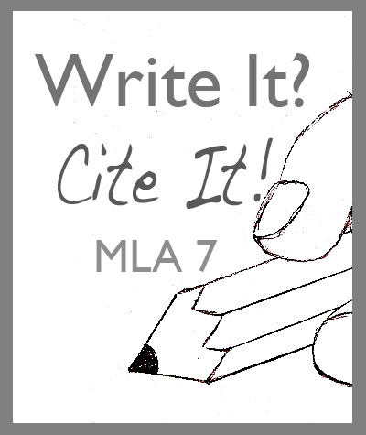
The following sites were used in the creation of this document:
“Guidelines for MLA Parenthetical Citations.” 9 Dec. 2006 <http://karn.ohiolink.edu/~sg-ysu/mlaguide.html>.
“Humanities: Documenting Sources.” 8 Dec. 2006 <http://www.dianahacker.com/resdoc/humanities/intext.html>.
“Signal Your Commentary on a Source.” 8 Dec. 2006 <http://www.uhv.edu/ac>.

